限免项目:

1、接口：

[http://iappfree.candou.com: ControllerData8080/free/applications/limited?currency=rmb&page=1](http://iappfree.candou.com:8080/free/applications/limited?currency=rmb&page=1)

内网:

<http://192.168.88.10/app/iAppFree/api/limited.php?page=1&number=20>

效果图:

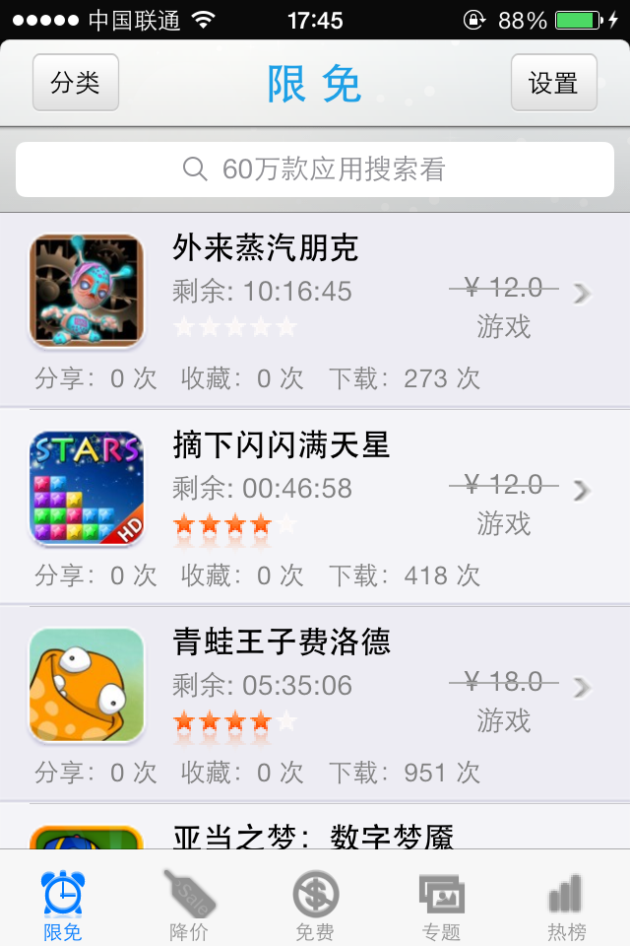

2、降价接口:

<http://iappfree.candou.com:8080/free/applications/sales?currency=rmb&page=1>

内网:

<http://192.168.88.10/app/iAppFree/api/reduce.php?page=1&number=20>

效果图:

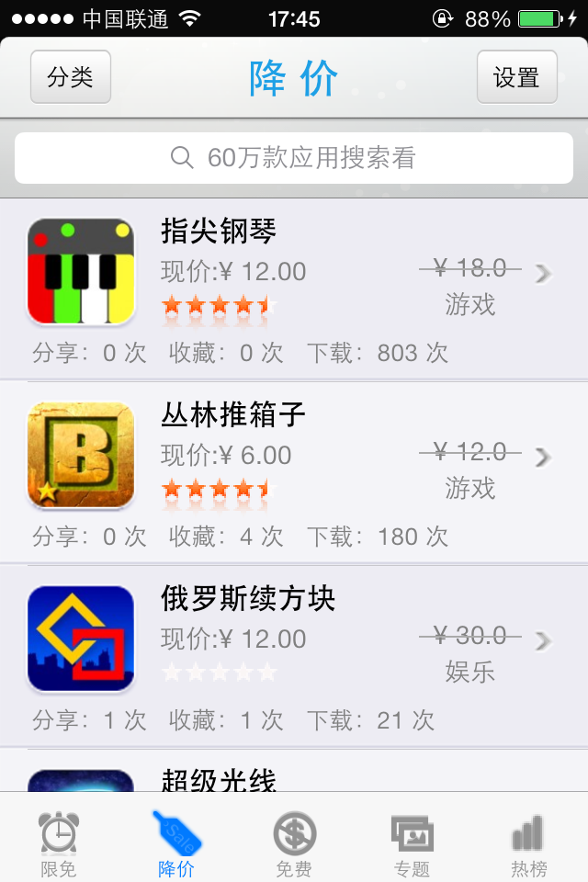

3、免费接口:

<http://iappfree.candou.com:8080/free/applications/free?currency=rmb&page=1>

内网:

<http://192.168.88.10/app/iAppFree/api/free.php?page=1&number=20>

效果图:

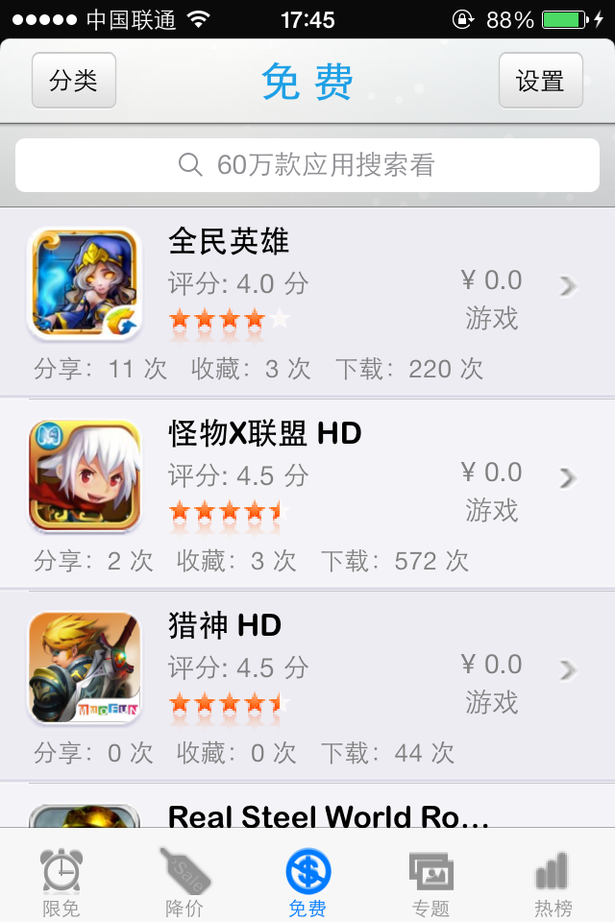

4、热榜接口:

<http://open.candou.com/mobile/hot/page/1>

内网:

<http://192.168.88.10/app/iAppFree/api/hot.php?page=1&number=20>

效果图 ：

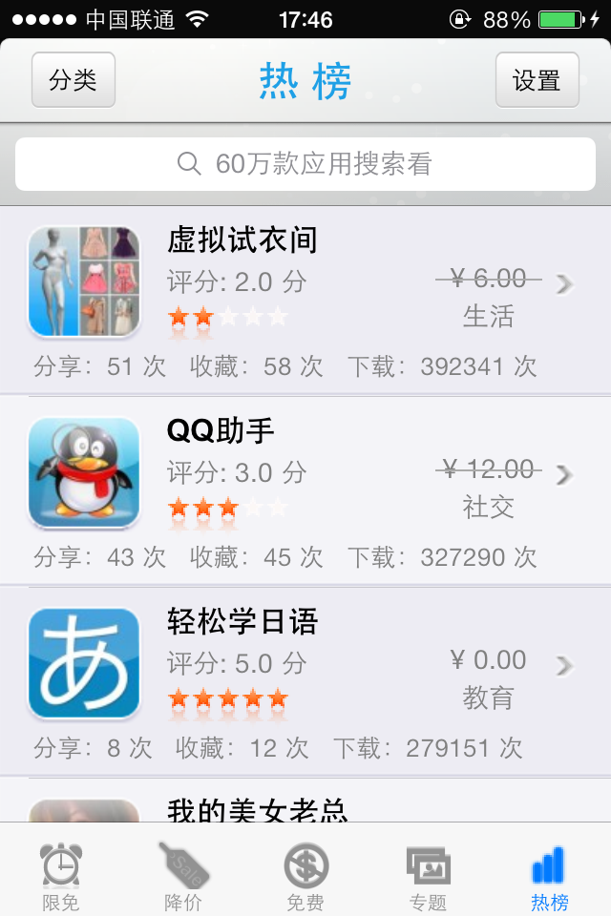

5、搜索接口:

[http://open.candou.com/search/app/word/%@/app/iphone/rank/0/start/1/limit/40](http://open.candou.com/search/app/word/%25@/app/iphone/rank/0/start/1/limit/40)

内网:

[http://192.168.88.10/app/iAppFree/api/limited.php?page=1&number=20&search=%@](http://192.168.88.10/app/iAppFree/api/limited.php?page=1&number=20&search=%25@)

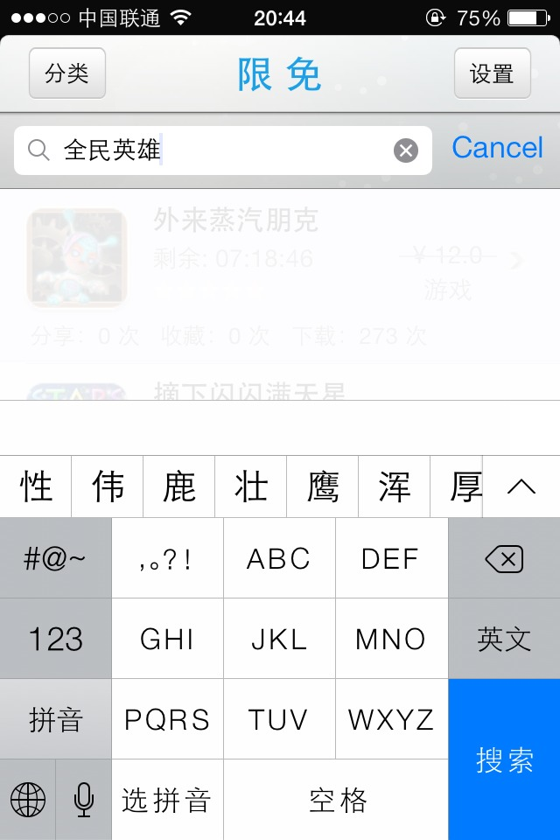

6、分类:

<http://open.candou.com/app/count>

内网:

<http://192.168.88.10/app/iAppFree/api/appcate.php>

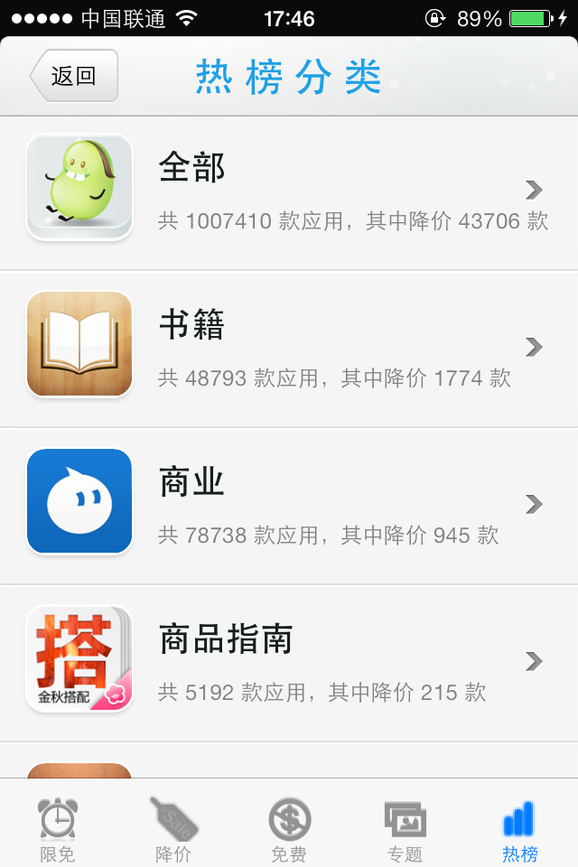

点击某一行后，将categoryid传递过去,拼接成请求地址:

<http://192.168.88.10/app/iAppFree/api/limited.php?page=1&number=20&cate_id=6014>

7、应用详情:

<http://iappfree.candou.com:8080/free/applications/561692374?currency=rmb>

内网:

<http://192.168.88.10/app/iAppFree/api/app.php?appId=661540006>

周边应用接口:

<http://iappfree.candou.com:8080/free/applications/recommend?longitude=116.344539&latitude=40.034346>

经度和纬度

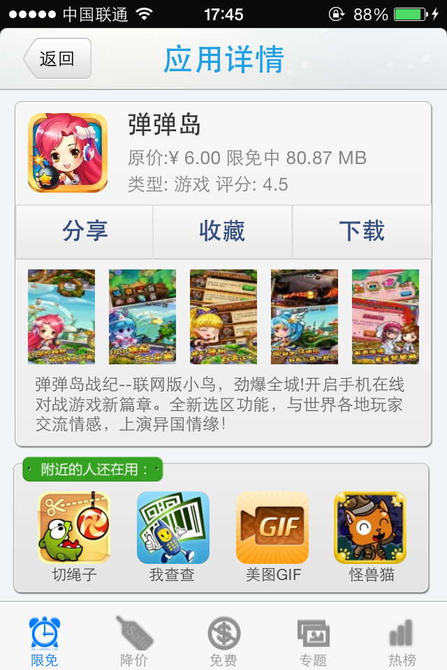

8、专题接口:

<http://iappfree.candou.com:8080/free/special?page=1&limit=5>

内网:

<http://192.168.88.10/app/iAppFree/api/topic.php?page=1&number=20>

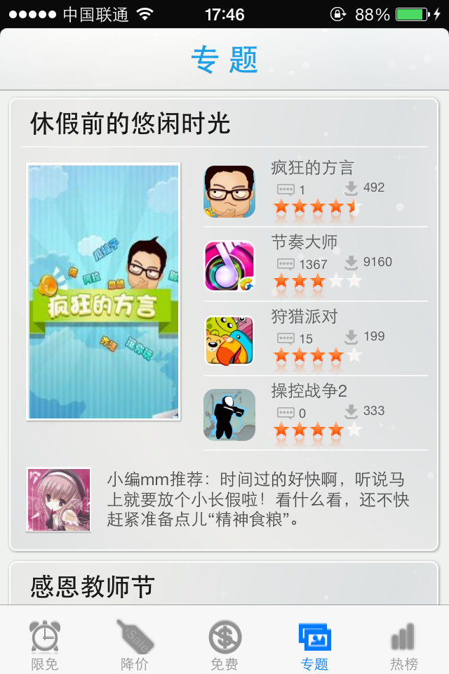

9、设置模块

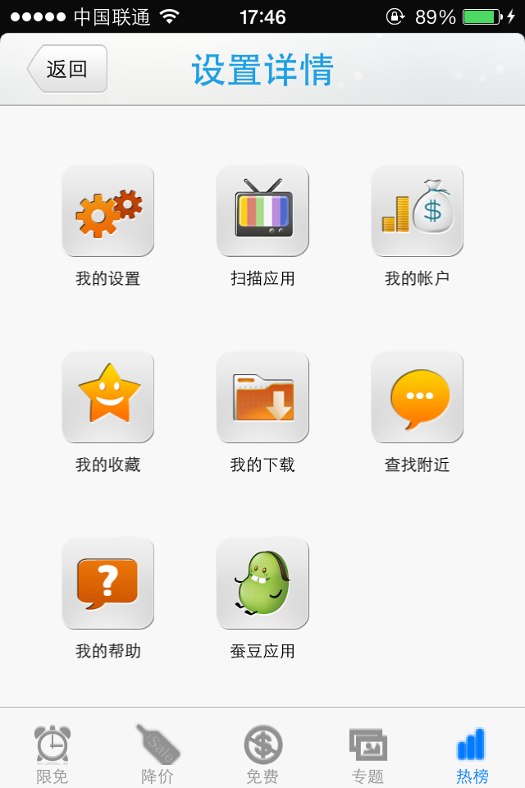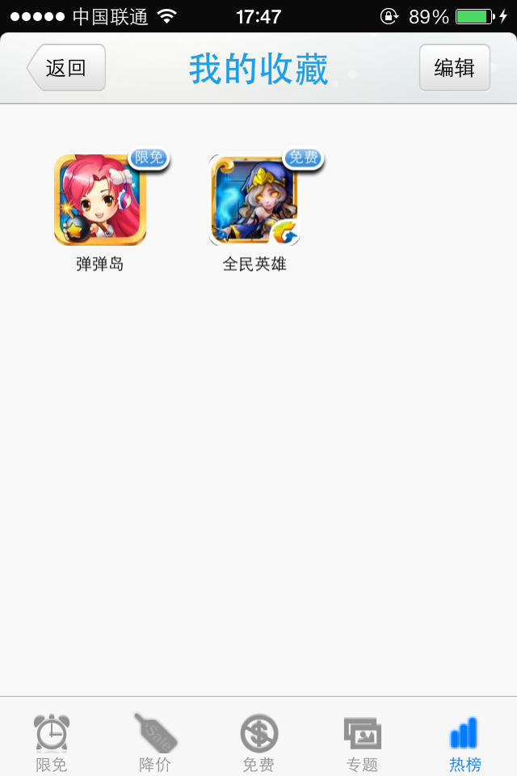

[UIColor colorWithRed:30/255.f green:160/255.f blue:230/255.f alpha:1];

[UIFont fontWithName:@"Arial Rounded MT Bold" size:22];